**Name: Stephen Akaeze**

**CSCI-E91 Cloud Devops: Assignment 1**

**Problem 1:**

1. The VM setup was successful with Ubuntu on 1 core, 4Gb ram, 10Gb secondary and default network connectivity.
2. Network connectivity was successful as shown demonstrated in using wget and curl commands as demonstrated in the screenshot below,

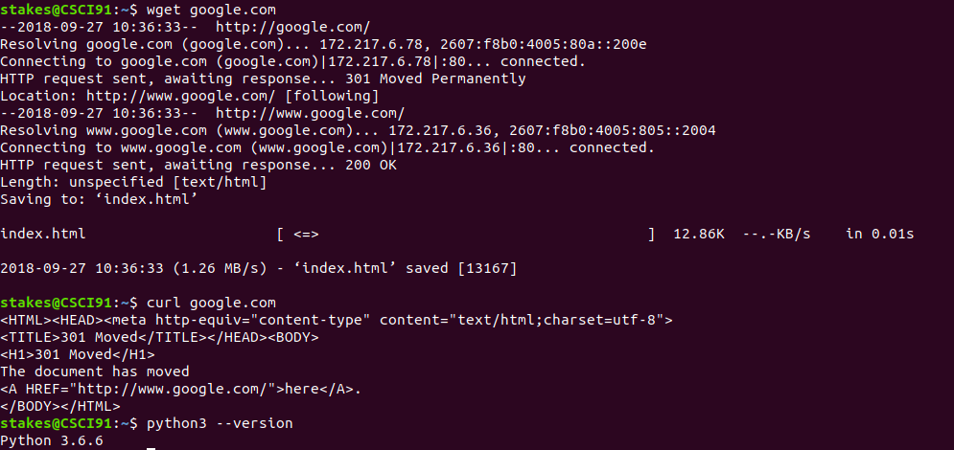

1. As also shown above, Python3 was already preinstalled in the ubuntu VM.
2. Pip3 and boto3 were successfully installed using the following commands
   1. *sudo apt-get install python3-pip*
   2. *sudo pip3 install boto3*
3. Notebook was installed successfully and Jupyter notebook ran using the following commands
   1. *sudo apt-get install notebook*
   2. *jupyter notebook*
4. My preferred Text editor is currently sublime

**Problem 2:**

1. My code.harvard.edu repository name is “cscie-91_sta83 and all teaching staff have been added as collaborators
2. The SSH keys were successfully created locally and public key uploaded to code.harvard.edu as evidenced by the keypair permissions and location shown in the image below

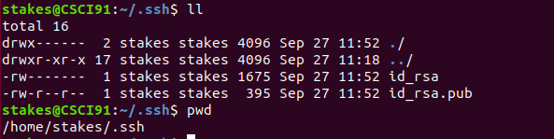

1. The git repository was successfully cloned locally and the README file modified, staged, committed and pushed as directed in the assignment instructions as shown below

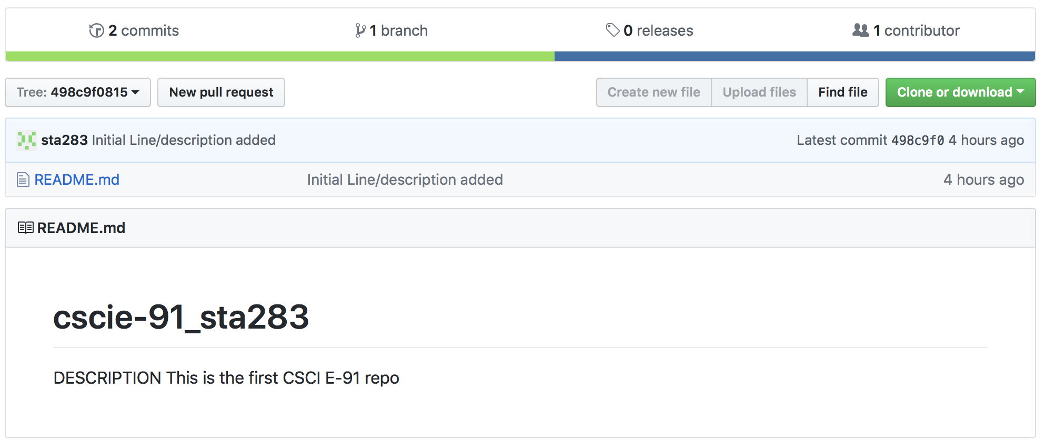

**Problem 3:**

1. The bash script was completed as named “system_data_script.sh” and its result named “system_data_script_result.txt” under “assignment1” directory in the repository
2. The python script was completed and named “max_int.py” under “assignment1” directory in the repository
3. The python script was completed and named “quote_dictionary.py” under “assignment1” directory in the repository

Please let me know if you have any concerns or questions. Thanks!